
Foundations of Programming

Assignment No. : 5
PROBLEM STATEMENT:
Write a program in C to perform basic matrix operations such as: 1. Addition of two matrices
- Saddle point of a matrix
- Inverse of a matrix
- Magic square of a matrix

OBJECTIVE:
- To understand matrix representation in C using two-dimensional arrays.
- To implement various matrix operations using C programming.
- To develop logical thinking for solving matrix-based problems.

THEORY:
Matrix operations are widely used in engineering and scientific applications. Addition of matrices involves adding corresponding elements. A saddle point is an element that is the minimum in its row and maximum in its column. The inverse of a matrix exists only for square matrices with non-zero determinant. A magic square is a square matrix in which the sums of elements in each row, column, and diagonals are equal. (ADD Example for 1. Addition of two matrices

Saddle point of a matrix 3. Inverse of a matrix 4. Magic square of a matrix
)
PLATFORM:
Linux
ALGORITHM:
- Start
- Read the order of the matrix
- Read elements of the matrices
- Perform matrix addition
- Check for saddle point
- Find inverse of the matrix (if determinant ≠ 0)
- Check whether the matrix is a magic square
- Display results
- Stop
FLOWCHART:
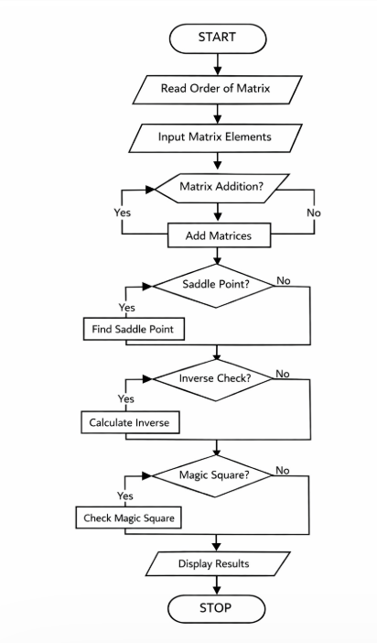

INPUT:
Matrix elements entered by the user. Type Input also paste Screen Shot of Input
OUTPUT:
Result of matrix addition, saddle point, inverse, and magic square verification. Type Outptu also paste Screen Shot of Output

CONCLUSION:
Thus, we have learned how to perform basic matrix operations using C programming and understood their practical applications.

CODE:
#include <stdio.h>

int main()
{
printf("ASSIGNMENT 5 "); int a[10][10], b[10][10], sum[10][10];
int i, j, r, c, k;
int min, saddle = 0, found = 0;

printf("Enter number of rows and columns: "); scanf("%d%d", &r, &c);

printf("\nEnter elements of Matrix A:\n");
for(i = 0; i < r; i++) for(j = 0; j < c; j++) scanf("%d", &a[i][j]);

printf("\nEnter elements of Matrix B:\n");
for(i = 0; i < r; i++) for(j = 0; j < c; j++) scanf("%d", &b[i][j]);

// FOR PERFORMING MATRIX ADDITION
printf("\nAddition of Matrices:\n"); for(i = 0; i < r; i++)
{
for(j = 0; j < c; j++)
{
sum[i][j] = a[i][j] + b[i][j]; printf("%d ", sum[i][j]);
}
printf("\n");
}

// SADDLE POINT
for(i = 0; i < r; i++)
{
min = a[i][0]; int col = 0;

for(j = 1; j < c; j++)
{
if(a[i][j] < min)
{
min = a[i][j]; col = j;
}
}

for(k = 0; k < r; k++)
{
if(a[k][col] > min) break;
}

if(k == r)
{
saddle = min; found = 1;
}
}

if(found) printf("\nSaddle Point = %d\n", saddle);
else printf("\nNo Saddle Point\n");

// FINDING INVERSE OF 2x2 MATRIX
if(r == 2 && c == 2)
{ float det; det = a[0][0]*a[1][1] - a[0][1]*a[1][0]; if(det == 0) printf("\nInverse not possible (Determinant = 0)\n");
else
{
printf("\nInverse Matrix:\n"); printf("%0.2f %0.2f\n", a[1][1]/det, -a[0][1]/det); printf("%0.2f %0.2f\n", -a[1][0]/det, a[0][0]/det);
}
} else
printf("\nInverse program is for 2x2 matrix only.\n");

// CHECKING FOR MAGIC SQUARE
if(r == c)
{
int rowSum, colSum, d1 = 0, d2 = 0; int magic = 1;

rowSum = 0; for(j = 0; j < c; j++) rowSum += a[0][j];

for(i = 0; i < r; i++)
{
int temp = 0; for(j = 0; j < c; j++) temp += a[i][j];

if(temp != rowSum)
magic = 0;
}

for(j = 0; j < c; j++)
{
int temp = 0; for(i = 0; i < r; i++) temp += a[i][j];

if(temp != rowSum)
magic = 0;
}

for(i = 0; i < r; i++)
{
d1 += a[i][i]; d2 += a[i][r-i-1];
}

if(d1 != rowSum || d2 != rowSum)
magic = 0;

if(magic) printf("\nMatrix is Magic Square\n");
else
printf("\nMatrix is NOT Magic Square\n");
} else
printf("\nMagic square possible only for square matrix\n"); return 0;
}
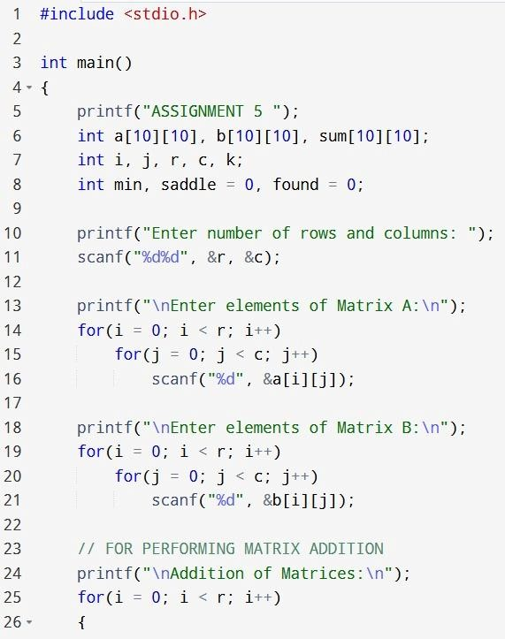

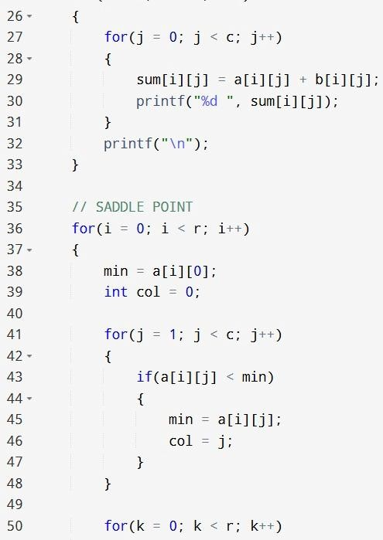
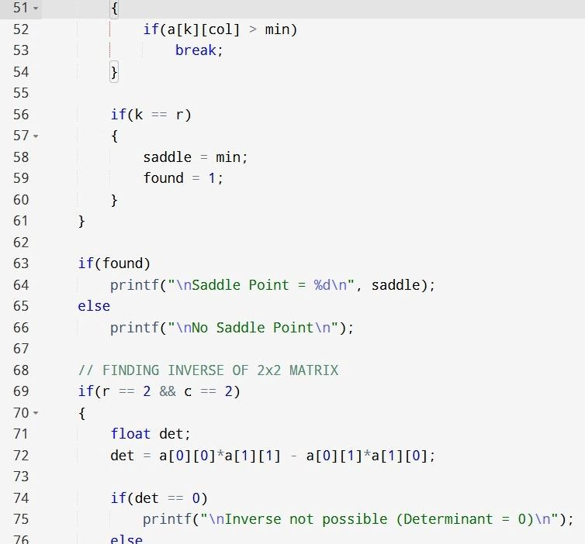

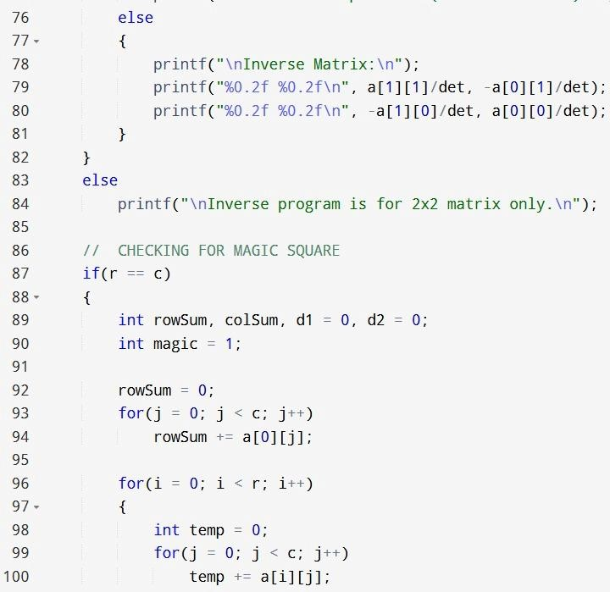

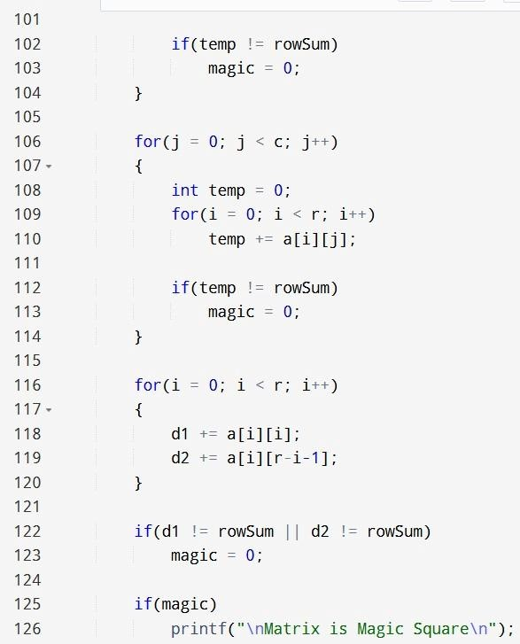

OUTPUT:
